# Report’s Outlook

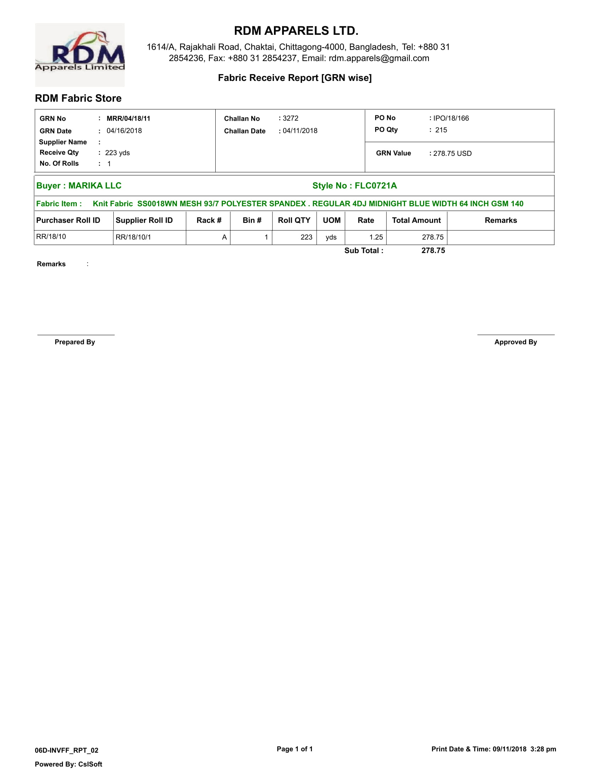

# Purpose of this report

# This report is the reference of challan wise fabric inventory receive.

# This challan may be po wise, CI wise or Independent.

# Essential info of the reports [Imp Values from the tables for calculation]

# List of Tables & Views

# Report’s Requirements:

Single SP/View with/without date range following

a. Company Group: Column, Group Company.

b. Company: Profit Centre / Licensed Company.

c. Factory Unit: It is production unit / factory.

d. Production Process: Name of the production process used in the factory.

e. Production Ref.: Production Reference [And it’s all data]

f. Buyer: Name of the Buyer

g. Style: Own style reference.

h. EPO [csv]: All EPO No. of the Production Reference will be CSV.

i. Shipment Date: Shipping of the Production Reference.

j. Reference Allotted Qty: Hourly Production

k. All process wise total update:

** Need to work on production update.

** For all date a single SP.

** Later filter

** Day wise & Later on Accumulate

# Report’s Descrption

**Cutting 🡪 Sewing 🡪 Finishing 🡪 Packing**

1. Production Unit
2. Production Ref. & date: Sort by date.
3. Style
4. EPO
5. Production Ref Qty
6. Cross tab of all Garments Process
7. **Cutting 7. Finishing**
8. **Printing 8. Packing**
9. **Embroidery**
10. **Sewing In**
11. **Sewing**
12. **Wash**

# SP Name:

# Change Requirements

# Production Reference Details:

Production Reference :

Factory :

Product Category :

Buyer Name:

Style Number :

Buyer PO :

Required Line Days :

Standard Minute:

Allotted Qty :

SAM :

No. of Work Station :

Organization Efficiency :

Daily Target Qty :

Line Planned :

Plan Start Date :